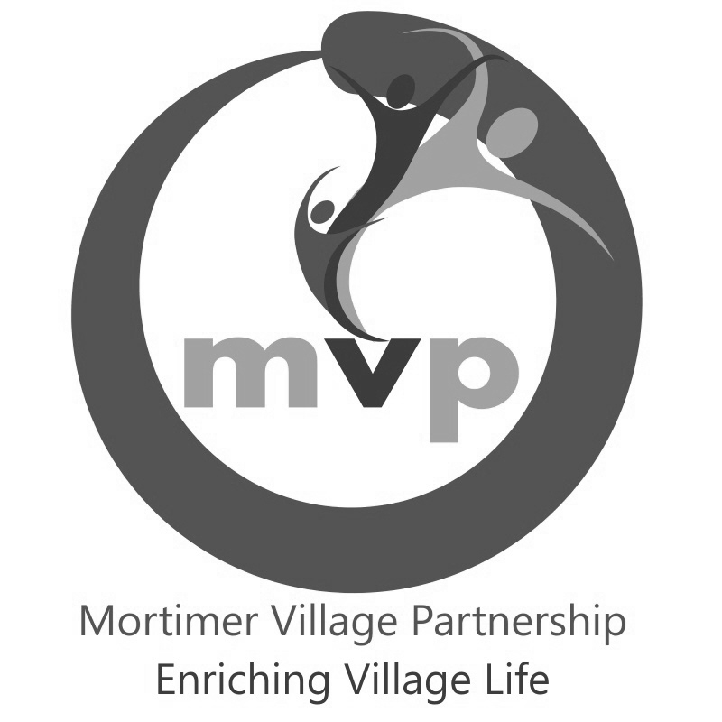
The Mortimer Village Scarecrow Trail, 2021
Theme: “ABCD”
Brought to you by the Mortimer Village Partnership
Saturday 23rd October – Sunday 31st October, 2021

Entry Form

Contact name: ________________________________________________________________
(Business, group, school or family)

Name to appear on sign: ________________________________________________________
(eg: blank, Smith Family, Rainbows Pre-School)
____________________________________________________________________________

Contact address: ______________________________________________________________

______________________________________ Postcode: ___________________________
Phone no: _____________________________ Mobile: __________________________

E-mail address: _______________________________________________________________

Chosen character / idea: ________________________________________________________

Exact address of location of scarecrow incl postcode (if different from contact address above):
____________________________________________________________________________

Please provide a question and answer relating to your character, for the trail 'Just For Fun Quiz'.
Question: ____________________________________________________________________

_______________________________________ One word answer: _____________________

Terms and Conditions
We undertake to maintain and display our scarecrow at the above location, from 9am on Saturday 23rd Oct until 4pm Sunday 31st Oct 2021. We also agree to abide by the rules and guidelines of the competition.
£10 entry fee is enclosed
Cheques to be made payable to Mortimer Village Partnership.
OR
£10 entry fee has been transferred via BACS to Mortimer Village Partnership
Sort Code: 601721, Account # 89207939
Use contact name above as reference

Completed entry forms (with payment if paying by cheque) must be returned to Julia Cooper at 6 Birchland Close, Mortimer RG7 3UG, or emailed to scarecrow@mortimervillage.org.uk no later than Monday 20th Sept 2021.
Please sign below on behalf of business, group, school or family stated above.
Name in block capitals: ______________________________________________________
Signature: ______________________________________________________
Mortimer Village Partnership
Scarecrow Trail, 2021
Rules and Guidelines
The theme this year is “A,B,C,D.” You can pick any character(s) or theme from the Authors: Issac Asimov, Raymond Briggs, Lewis Carroll or Roald Dahl, so get creative!

Competition Rules
- The competition and trail starts at 9am on Saturday 23rd October and runs until 4pm Sunday 31st October.
- Scarecrows need to be visible each day of the trail from 9am until dusk.
- Scarecrows need to be maintained, as far as possible, in good condition for the duration of the trail.
- The organisers will provide a laminated A4 poster. If, for some reason, the scarecrow is not available the poster must still be displayed for trail followers to see.
- The organisers will take photographs of all the registered scarecrows on the first day. Registration of a scarecrow permits the Mortimer Village Partnership to use the photos on social media and in promotional literature/displays.
- Duplicate characters will NOT be allowed and the acceptance of characters will be made on a first come first served basis. Confirmation of entry acceptance will be sent by the organisers.
- If the organisers have to limit the number of scarecrows, priority will be given to early entrants. Some entrants may be asked to consider alternative locations for their scarecrows in order to maintain a reasonably spaced and balanced trail.
- There will be three winning categories of scarecrow: the funniest scarecrow; the favourite scarecrow – adult's choice; the favourite scarecrow – children's choice. The winning scarecrows will be decided by votes from members of the general public who have purchased a trail map. A scarecrow may only win one category and the organisers decision is final.
- There will be a runner up prize for each of the 3 winning categories of scarecrow and an additional winning scarecrow as chosen by the MVP Chair. The owners of the winning scarecrows will each receive £50 with the runner up receiving £25.
- Completed entry forms must be returned to Julia Cooper at 6 Birchland Close, Mortimer, Berkshire, RG7 3UG, or via email to scarecrow@mortimervillage.org.uk no later than Monday 21st September 2021, either with entry fee or confirming BACS payment has been made.
- There will be a trail competition for all trail followers who have purchased a map. The winner of the trail competition will be drawn from all correct entries and will receive £25.00. The organisers decision is final.
N.B. Organisers refer to the Scarecrow Committee, Mortimer Village Partnership.
Entrants refer to families, individuals, organisations, groups, businesses etc. registering/ entering a scarecrow into the competition.

Competition Guidelines follow on -

Guidelines
- Above all the Scarecrow Trail is all about having fun – we hope that you do!
- This year the primary concern remains the safety and well being of everyone who participates in the trail. Please consider siting your scarecrow where it gets the widest view from your property to avoid people “crowding” whilst viewing. Consider the size and position of the Scarecrow so that it may be viewed from a distance.
- When making your scarecrow, think about the theme and the characteristics and/or situation that will make your choice of scarecrow instantly recognizable.
- Scarecrows can be made in a traditional format i.e. based around a cross shaped frame and making use of straw etc. or as a modern interpretation.
- Face masks, paper mache and other materials may all be used but thought should be given to how these will stand up to the elements throughout the duration of the Scarecrow Trail.
- It is recommended that scarecrows in the front garden of private houses are set back from their front boundary fences to minimize the risk of vandalism. Commercial premises may wish to display their scarecrow either standing or seated outside during the hours they are open and, in their windows, whilst they are closed. When making the scarecrow, take into consideration how easy it will be to move it, if required.
- Scarecrows can be standing, seated, lying down and posed as if participating in an activity.
- Consider making a “storyboard” of the construction of your scarecrow to display alongside for trail followers to look at.

If you have any further questions please contact Doug Overett, 07738 470870.
www.mortimervillage.org.uk
Find us on Facebook. Mortimer Scarecrow Trail

