As the perpetual rain has finally given way to sunshine, and the young people of 1st Burghfield and Sulhamstead Scouts have been enjoying nature and the outdoors.

Our Pathfinder Beavers made crowns to celebrate the coronation and decorated cup cakes.

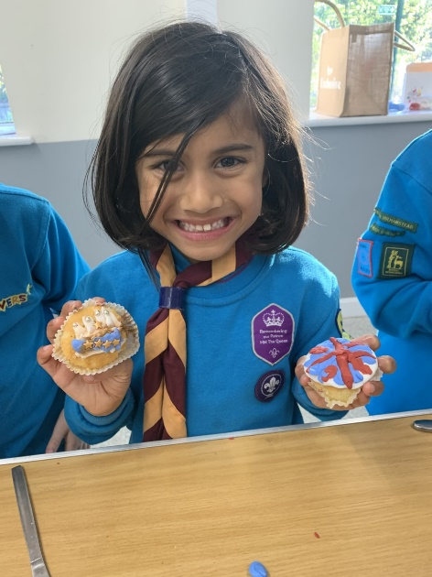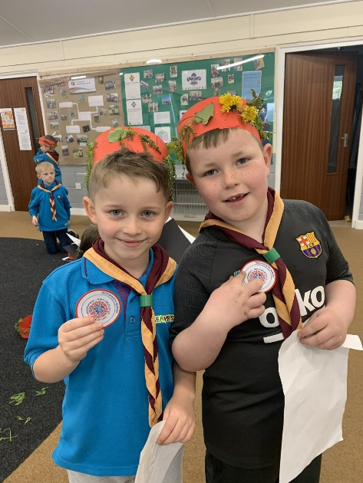

Our cubs had the opportunity to attend Cubjam - an action-packed themed camp, journeying through time with Romans, Egyptians, Greeks and Ancient Britons. Cubjam offered activities, entertainment and the opportunity to make friends with Cubs from across the Country.

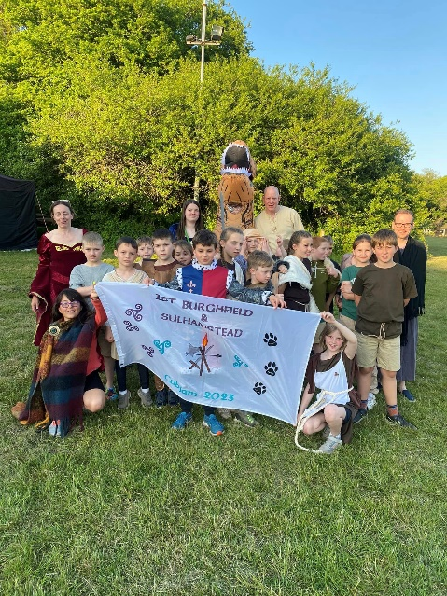

Our Hawks Scout troop visited Cotswold outdoors shop to learn about equipment and gear up for our camp trips, which included a memorial hike in memory of late Mortimer scout leader Skip Johnson and a survival camp in hammocks under the stars.
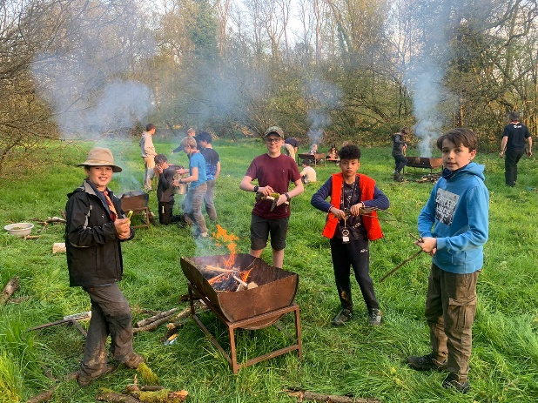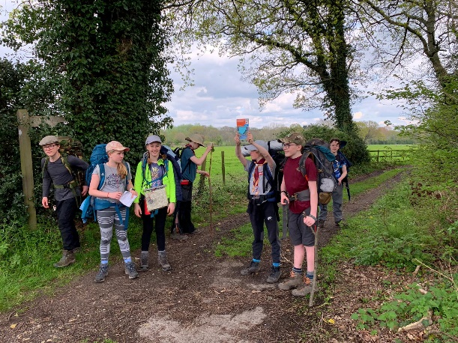

Hawks also engaged in an inter-troop cooking competition, slot car racing, a zoom call with a Danish troop, practised circus skills, met a guide dog, and ran a greasy pole activity at the Mortimer coronation event.

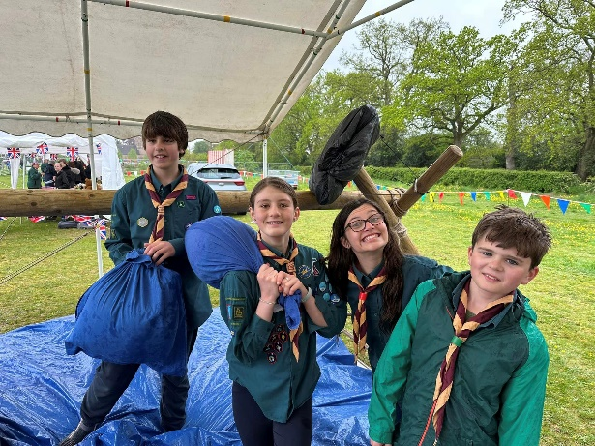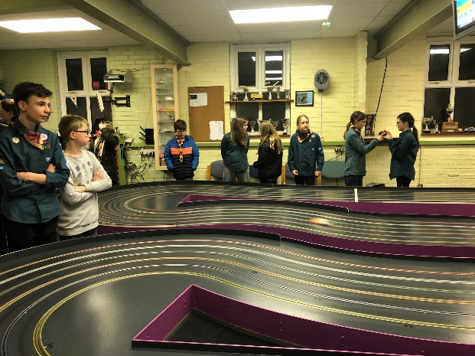

Falcon Scouts had a go at making their own sausages and grilled them over the campfire. The results were tasty, including a veggie alternative with quite an involved list of ingredients and kitchen gadgets.

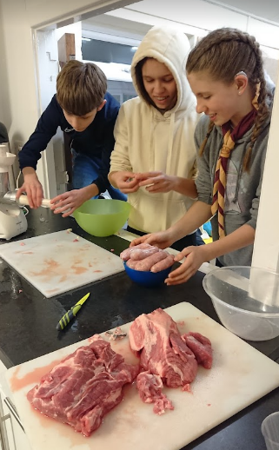

Falcons also held their first photography skills night - learning to use the manual modes for trick photography and photo editing. We managed to write words with a torch, film some short stop motion Lego movies, add colour pops to images and even got photos of scouts hanging out of a toy helicopter like it was life size!

TAO Explorers have been doing lots of cooking (bake off, cooking science experiments, cardboard pizza ovens), as well as working on our general pioneering skills in preparation for the river crossing challenge later in the term.

We also joined other units from the district and participated in the 'Monopoly Run Live' in central London. Explorers spent the day in London in groups of 6 or 7 racing around London to see who could make the most money!

