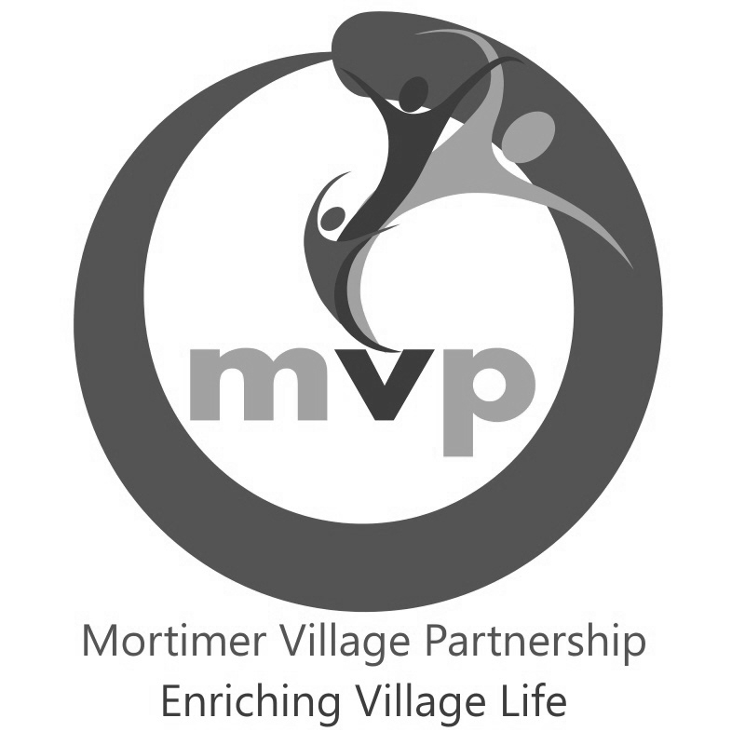
The Mortimer Village Scarecrow Trail, 2026
“Game On!”
Brought to you by the Mortimer Village Partnership
Saturday 24th October – Sunday 1st November

Entry Form

Contact name: ________________________________________________________________
(Business, group, school or family)

Name to appear on sign: ________________________________________________________
(eg: Smith Family, Rainbows Pre-School)
____________________________________________________________________________

Contact address: ______________________________________________________________

____________________________________________________________________________
Postcode: __RG7_________________ Phone / Mobile no: ___________________________

E-mail address: _______________________________________________________________

Chosen character / idea: ________________________________________________________

Exact address of location of scarecrow incl. postcode (if different from contact address above):
____________________________________________________________________________

Please provide a question and answer relating to your character, for the trail 'Just For Fun Quiz'.
Question: ____________________________________________________________________

____________________________________ One word answer: ________________________

Terms and Conditions
We undertake to maintain and display our scarecrow at the above location, from 9am on Saturday 24th October – until 4pm Sunday 1st Nov 2026. We also agree to abide by the rules and guidelines of the competition (outlined below).
o £10 entry fee has been transferred via BACS to Mortimer Village Partnership
Sort Code: 60-17-21, Account # 89207939
Please use your given contact name as reference, plus ‘SCT’ (e.g. ‘SmithSCT’)
OR
o £10 entry fee is enclosed.
Cheques to be made payable to Mortimer Village Partnership.

This completed entry form (with payment if paying by cheque) must be returned to Mike Rogers, Meadowside, Windmill Road, Mortimer, RG7 3RJ, or emailed to scarecrow@mortimervillage.org.uk no later than Friday 18th September 2026.
Please sign below on behalf of business, group, school or family stated above.
Name in block capitals: ______________________________________________________
Signature: ______________________________________________________
Mortimer Village Partnership
Scarecrow Trail, 2026 - Rules and Guidelines

The theme this year is “Game On!”, you can choose any character(s) you like, based on this theme, and we encourage recognisable figures where possible.
Competition Rules
- The competition and trail starts at 9am on Saturday 24th October and runs until 4pm Sunday 1st November.
- Scarecrows need to be visible each day of the trail from 9am until dusk.
- Scarecrows need to be maintained as far as possible in good condition for the duration of the trail.
- The organisers will provide a laminated A4 poster. If for any reason the scarecrow is not available, the poster must still be displayed for trail followers to see.
- The organisers will take photographs of all the registered scarecrows on the first day. Registration of a scarecrow permits the Mortimer Village Partnership to use the photos on social media and in promotional literature/displays.
- Duplicate characters should be avoided; you will be advised by email if someone has already reserved your character.
- If the organisers have to limit the number of scarecrows, priority will be given to early entrants. Some entrants may be asked to consider alternative locations for their scarecrows in order to maintain a reasonably spaced and balanced trail.
- The prize categories are as follows:
Category | Who Votes? | First Prize | Second Prize
Funniest | Trail followers via trail map | £50 | £25
Children’s Favourite | Trail followers via trail map | £50 | £25
Adults Favourite | Trail followers via trail map | £50 | £25
Most eco-friendly | MVP Committee | £50 | £25
Best Newcomer (must not have entered a scarecrow before) | MVP Committee | £50 | -
Chairman’s Choice | MVP Chairman | £50 | -
A scarecrow may only win one category and the organisers’ decision is final.
- Completed entry forms must be returned to Mike Rogers, Meadowside, Windmill Road, Mortimer, RG7 3RJ, or via email to scarecrow@mortimervillage.org.uk no later than Friday 18th September 2026, either with entry fee or (preferably) confirming BACS payment has been made.
- There will be a trail competition for all trail followers who have purchased a map. The winner of the trail competition will be drawn from all correct quiz entries and first prize will receive £50.00
N.B. Organisers refer to the Scarecrow Committee, Mortimer Village Partnership.
Entrants refer to families, individuals, organisations, groups, businesses etc. registering/ entering a scarecrow into the competition.
Competition guidelines on next page -

Guidelines & Additional Information
- Above all the Scarecrow Trail is all about having fun – we hope that you do!
- When making your scarecrow, think about the theme and the characteristics and/or situation that will make your choice of scarecrow instantly recognizable.
- Any materials may be used. Thought should be given to how they will stand up to the elements throughout the duration of the Scarecrow Trail. And remember there’s an eco-friendly scarecrow prize!
- It is recommended that scarecrows in the front garden of private houses are set back from their front boundary fences to minimize the risk of vandalism.
- Commercial premises may wish to display their scarecrow either standing or seated outside during the hours they are open and, in their windows, whilst they are closed. When making the scarecrow, take into consideration how easy it will be to move it, if required.
- Scarecrows can be standing, seated, lying down and/or posed as if participating in an activity.
- Consider making a “storyboard” of the construction of your scarecrow to display alongside for trail followers to look at.
- Why not join the Makers page on Facebook for hints and tip from other builders: https://www.facebook.com/groups/428613623937557

If you have any further questions please contact Doug Overett, 07738 470870
or email scarecrow@mortimervillage.org.uk
www.mortimervillage.org.uk

Thank you

